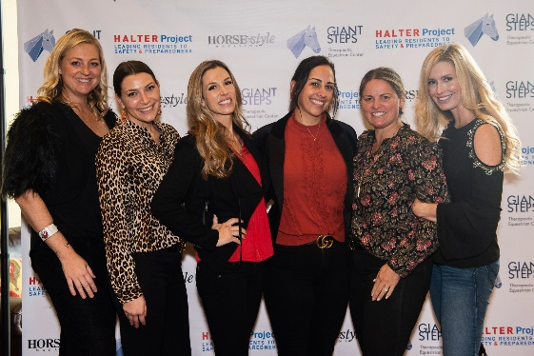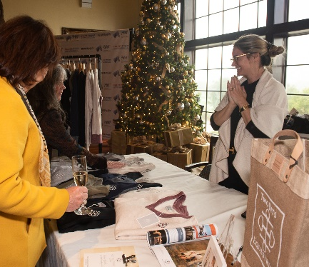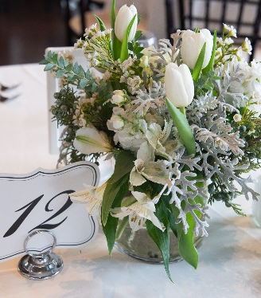

Sponsorship Benefits

The benefits below are suggested, but we are happy to tailor to sponsor needs.

Title Sponsor, Platinum Level – $2,500 (one available)
- Exclusive naming rights of event: Horse & Style Magazine Holiday Boutique, Presented by your name here
- Logo on Step and Repeat banner (purchased before November 14th)
- Logo/link to your website on the home page of giantstepsriding.org, through 2023
- Opportunity to speak at the event
- Table for eight
- Option to include item in gift bags
- Logo on invitation (if sponsorship is purchased before October 10th)
- Link to your website on event website
- Recognition in pre-event emails
- Recognition on Giant Steps social media (Facebook 4.6k+, Instagram 9.3k+) once a month pre-event starting October 2022, and once post-event
- Recognition in the Giant Steps digital newsletter (2.4k+ subscribers)

Gold Sponsor – $1,000 (three available)
- Tickets for four
- Option to include item in gift bags
- Logo on invitation (if sponsorship is purchased before October 10th)
- Link to your website on event website
- Recognition in pre-event emails
- Recognition on Giant Steps social media (Facebook 4.6k+, Instagram 9.3k+) once a month pre-event starting October 2022, and once post-event
- Recognition in the Giant Steps digital newsletter (2.4k+ subscribers)

Silver Sponsor – $500 (five available)
- Tickets for two
- Link to your website on event website
- Recognition in pre-event emails
- Recognition on Giant Steps social media (Facebook 4.6k+, Instagram 9.3k+) once pre-event, and once post-event
- Recognition in the Giant Steps digital newsletter (2.4k+ subscribers)

To purchase a sponsorship, visit https://HSshop22.givesmart.com. If you would prefer to pay by check and avoid the processing fee, please make it out to “Giant Steps” and mail to our office:
1390 N. McDowell Blvd, Suite G331, Petaluma, CA 94954

Tax identification 68-0404917

